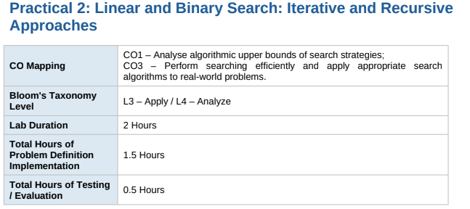
Practical Aim
To implement linear and binary search using both iterative and recursive approaches.
Problem 1
A security guard at a parking lot checks vehicles one by one from the entrance to find a car with a specific license plate. Sometimes he starts from the entrance, sometimes he calls a helper who starts from where the guard left off. Given a list of license plates and a target plate, implement both approaches — one that checks plates one by one from the start, and one where the function calls itself to continue checking — and report the position of the target plate if found.
Describe the approach you used. What happens in your solution if the target plate appears more than once in the list? Does it find the first occurrence, the last, or just any one?
CODE:
#include <iostream>
using namespace std;

// Iterative Linear Search
int linearIterative(int a[], int n, int target) {
for (int i = 0; i < n; i++) {
if (a[i] == target)
return i;
}
return -1;
}
// Recursive Linear Search
int linearRecursive(int a[], int n, int target, int i) {
if (i == n)
return -1;

if (a[i] == target)
return i;

return linearRecursive(a, n, target, i + 1);
}
int main() {
int a[] = {25, 12, 45, 30, 18, 45};
int n = 6;
int target = 45;

int result1 = linearIterative(a, n, target);
int result2 = linearRecursive(a, n, target, 0);

cout << "Iterative Search Position: " << result1 << endl;
cout << "Recursive Search Position: " << result2 << endl;

return 0;
}
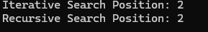

Problem 2
A librarian maintains a sorted catalog of book codes and needs to locate a specific code quickly. Instead of going through every book, she opens the catalog to the middle, checks whether the target is to the left or right, and repeats. Given a sorted list of book codes and a target code, implement both approaches — one using a loop and one where the function calls itself — and report the position of the target code. Describe the approach you used. What is the one condition your input must satisfy for this approach to work correctly? What would go wrong if that condition was not met?
CODE:
#include <iostream>
using namespace std;

// Iterative Binary Search
int binaryIterative(int a[], int n, int target) {
int low = 0;
int high = n - 1;

while (low <= high) {
int mid = (low + high) / 2;

if (a[mid] == target)
return mid;
else if (target < a[mid])
high = mid - 1;
else
low = mid + 1;
}

return -1;
}// Recursive Binary Search
int binaryRecursive(int a[], int low, int high, int target) {
if (low > high)
return -1;

int mid = (low + high) / 2;

if (a[mid] == target)
return mid;
else if (target < a[mid])
return binaryRecursive(a, low, mid - 1, target);
else
return binaryRecursive(a, mid + 1, high, target);
}

int main() {
int a[] = {10, 20, 30, 40, 50, 60, 70};
int n = 7;
int target = 50;

int result1 = binaryIterative(a, n, target);
int result2 = binaryRecursive(a, 0, n - 1, target);

cout << "Iterative Search Position: " << result1 << endl;
cout << "Recursive Search Position: " << result2 << endl;

return 0;
}
